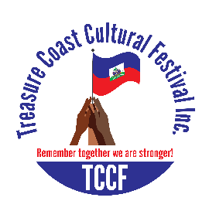
TREASURE COAST CULTURAL FESTIVAL PAGEANT

Greetings!

I would like to invite you to become a sponsor of the “Treasure Coast Cultural Festival Pageant”, May 1, 2020
To be held at 4600 Kirby Loop Rd, Fort Pierce, FL 34981
We are a non-profit organization 501 C (3) and we are diligently working with the youth in the community to help them build their self-esteem; boost their confidence for a better community. While participating in this pageant our kids, teens, young adults, and adults will be walking on the stage like a pro, they will also gain knowledge by learning about culture, history, because at TCCF we truly value education.

This would be a wonderful opportunity for your organization to help shape the society for the better meanwhile you will be having exposure for your business. You will be expose on our flyer, radio, website, Facebook, stage. Every year it’s getting bigger and better let’s get together, support each other for a better tomorrow.

Thank you for helping make a difference.
Below are options designed to assist you in finding the right level for your budget. Please review and let me know if you have any questions. You can mail or email your interest level. We look forward to an affirmative response of sponsorship from you to make this event successful.

My best regards,

Carole King
Founder/President

Treasure Coast Cultural Festival, Inc.
7410 S US HWY 1
Port St Lucie, FL 34952
Tel: 772-240-3039
772-932-8223
Website: www.mytccf.com
Facebook: treasure coast cultural festival
REMEMBER TOGETHER WE ARE STRONGER!

Check the sponsorship level of your choice:

___________ Level 1: Age 18 and up $200.00

___________ Level 2: Age 12 to 17 $150.00

___________ Level 3: Age 4 to 11 $100.00

Any donation will be appreciated

Sponsorship Agreement Form
Organization Name:
Contact Name:
Title:
Address:
City/State/Zip:
Email:
Phone:
Fax:
Web:
By executing this legally binding agreement, I agree to:
• indemnify, defend, and hold harmless the “Treasure Coast Cultural Festival, Inc.” pageant planning committee and host organizations and their agents and employees from any and all such losses, damages, and claims.

___________________________________________________________________________________
Printed Organization Name

___________________________________________________________ _________________
Signature Date

Please return this agreement to the contact person. An invoice for payment will be sent to you. You can pay by cash app, Zell, money order or wire transfer.

