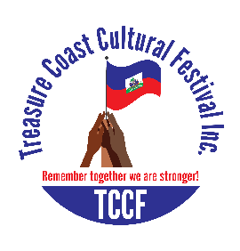
TREASURE COAST CULTURAL FESTIVAL, INC.
2019 MISS & MISTER PAGEANT

DATE: MAY 4^{TH,} 2019
TIME: 6:00PM-9:00PM
LOCATION: 4600 Kirby Loop Rd, Fort Pierce, FL 34981
PLEASE ATTACH A SMALL PHOTO
APPLICATION ARE DUE BY 01/31/2019
Send Application to P.O. Box 881124 PSL FL, 34952

DATE OF APPLICATION: _________________
NAME: ______________________________________________________________________________
AGE: _____ DATE OF BIRTH: __________________BIRTHPLACE: ____________________
ADRESS: ____________________________________________________________________________
EMAIL: _________________________________PHONE#: _________________________________
SCHOOL/COLLEGE________________________GRADE/YEAR OF COLLEGE_______
SIZE: ___________________________________
AGE GROUP (PLEASE CHECK ONE)
KIDS 4-12YRS [ ]
TEEN 13-19 YRS [ ]
ADULTS 20-54 YRS [ ]
SENIOR 55 & UP [ ]

Talent(s): _______________________________________ Hobbies/Interests: _________________________________
Dream Career/Current Career: _________________________
One thing that you like about the Haitian Culture: ______________________________________________________

Contestant’s Signature Parent/ Guardian’s Signature
X_________________________ X_______________________________

Officials Use Only
Date Received_____________
Receipt Given _________
Revised: Oct 2017….CV

RULES AND REGULATIONS

-Contestant must be of Haitian decent (at least one parent or grandparent is Haitian)
-Contestant must be in good standard on social media (i.e. no nudity, no profanity)
-Photos must be in 8x10 with contestant’s full name and age clearly printed on the back
-Provocative photos will not be accepted
-Contestant must attend at least 2 practices at the time scheduled
-Contestant will be responsible for their own transportation, make up and outfits
-Contestant is advised to sell tickets to family and friends or coworkers
-Contestant that sells a minimum 10 tickets will win a prize
-Contestants must obtain a TCCF 2019 Pageant t-shirt at $10
-Contestants under 15yrs old must be accompanied by an adult
-TCCF will not be responsible for loss and damage of personal belongings
-TCCF deserve the rights to disqualify any contestants for misconduct
-Contestants must post a short video or photo on TCCF Fakebook’s page to collect likes. The contestant with the most like will receive the People’s Choice Award
-Application received without the cost of t-shirt and photo will not be accepted, no exception

